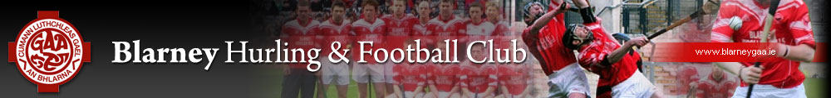

Blarney/Rathpeacon GAA

Club Na nÓg
5 & 6 years of age

UNDERAGE
Skills of Hurling

5 & 6 years of age

Produced by: Niall Hayes
23rd May 2016

Introduction

All children aged 5 and 6 years of age should have mastered the skills outlined below by the end of their time in these years and before they reach the Under 7’s group. Coaches do not have to focus solely on these skills but each player must be proficient in these skills by the end of their two year period. These skills were chosen as a result of a search of as many GAA support materials as possible and from experience in what skills are needed in Go Games and training sessions to progress the skills of hurling.

5 AND 6 YEAR OLD CHILDREN
SUGGESTED SKILL FOCUS

Aged 5 years and 6 years
GRIP

READY POSITION AND LOCK

SWING

ABC’S
(Agility, Balance, Coordination)

STOP A BALL

STRIKE A STATIONARY BALL

DRIBBLE A BALL

GO GAMES

FUN

Coaching Session Set Up

Each coaching session should incorporate 4 skills, games involving ABC’s and FUN. The session should last no longer than 1hr and 15 minutes.

SESSION FORMAT

The session should be organised as follows:

- Warm up to include ABC’s 10 minutes (MAX)
- Drill Stations x 4 7 minutes at each station
- Go Games 10 to 15 minutes

- Finish with the children collecting the equipment, shaking of hands with each other and presenting a reward sliothar to those who try the hardest.

REQUIREMENTS FOR A SUCCESSFUL SESSION

A group of coaches/parents need to be organised with one lead coach that rotates. The lead coach will time and coordinate the session. This requires two needs:-
- The Sessions must be pre-planned and organised
- There must be at least 4 coaches/parents involved in the session.

Coaches should arrive 20 minutes before the session for set up purposes. All coaches who participate in the session must be talked through the session by that day’s lead coach. It is vital that the lead coach role is rotated to involve as many coaches/parents as possible.

EQUIPMENT
Coaches are encouraged to use the full range of equipment available to them which include bean bags for catching/throwing, cones for organising lines/targets/games, poles for marking off areas for games, hurdles for jumping, hula hoops for games, tyres for striking etc...

The equipment is available from the equipment room every Saturday morning which will be open at 10:45am to start training at 11:15am.

WARM UP SUGGESTED EXAMPLES
These are warm-up exercises that may be used before any other ABC or Have-a-Ball exercise. They include pulse raising and mobilisation exercises.
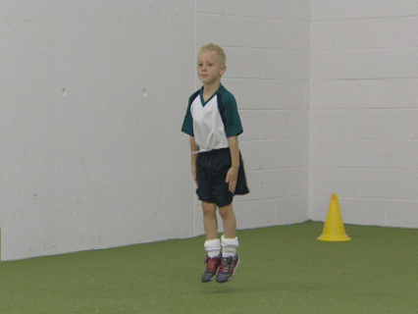
Organisation
- Begin with moderate exercises such as walking or light jogging before moving on to more intense activity
- Incorporate mobilisation exercises at regular intervals between the pulse raising exercises
- Include basic jumping movements such as hopping like a rabbit, jumping like a frog to prepare for jumping exercises to follow
Key Points
- Gradually increase the intensity of the activity
- Include a moderate version of activities to be performed later in the session
Equipment
- No equipment needed
This exercise to develop coordination skills is generally suitable for players of 4-6 years of age.
Saucer and Tea Cups Game
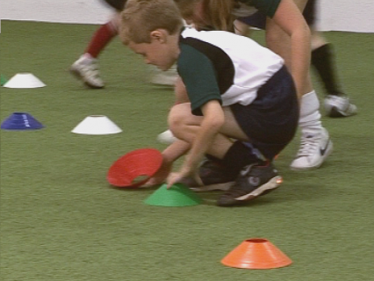
Organisation
- Place a number of cones or domes around the playing area
- The players run around the playing area turning the cones or domes
- The exercise can be run using two teams; one team attempts to turn all the cones up while the other attempts to turn all the cones down
Key Points
- Coordination and movement is key and spread out the cones
Equipment: - Cones
This exercise to develop coordination skills is generally suitable for players of 4-6 years of age.
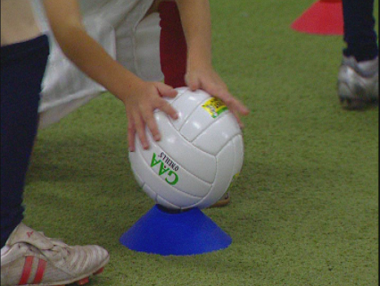
This exercise requires the players to move balls from cone to cone
Organisation
- Place a number of cones randomly around the playing area; place a number of balls on half the cones
- The players move the balls from cones to cones as they move around the playing area
Key Points
- Ensure the players have enough room to move around safely
- No pushing or bumping
Equipment
- Cones, Sliothars, Footballs,

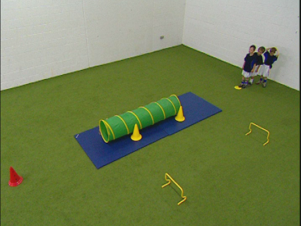
This is an exercise to develop coordination, balance and running skills
Organisation
- Place different obstacles, for example a tunnel, cones and jumps around the playing area
- The players negotiate the course as quickly as possible
Key Points
- Ensure the players have enough room to move around safely
- Provide safety mats where necessary
Equipment
- Cones, Poles, Hurdles, hula hoops, ladders, sliothars

Blarney GAA Skills Evaluation Form
 | PLAYER | SKILL | EVALUATION
 |  |  | STRONG | NEEDS PRACTICE | NOT STRONG
1
2
3
4
5
6
7
8
9
10
11
12
13
14
15
16
17
18
19
20
21
22
23
24
25
26

